Educating Parents about Social Media

As a school, we want you to continue to be educated as social networking continues to be on the rise. In an effort to keep online interactions safe, productive and positive, we hope to provide you with some information on some of the applications students are using today.
For helpful information and research on applications please visit: https://www.commonsensemedia.org.

Yik Yak

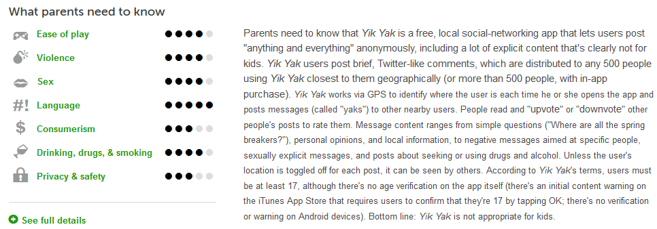

Snapchat
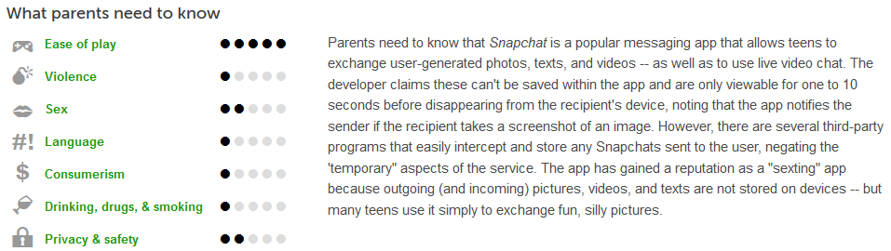

Kik Messenger
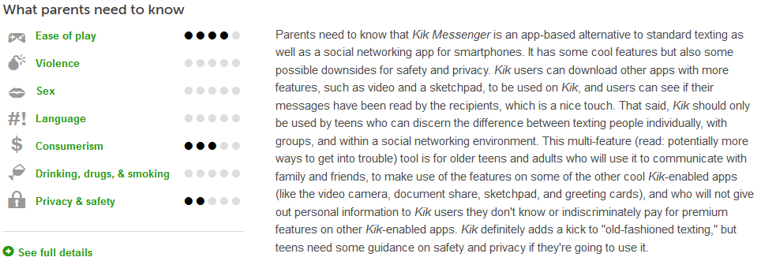

Twitter

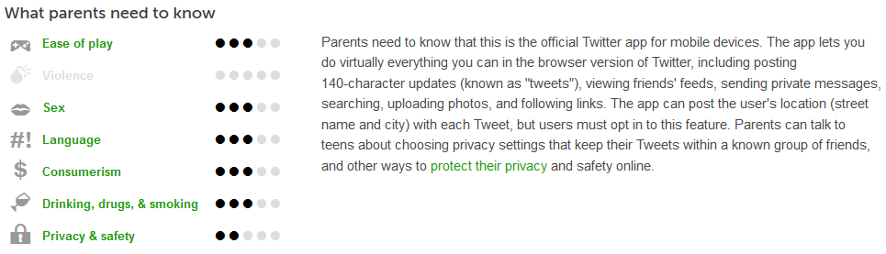

Facebook

